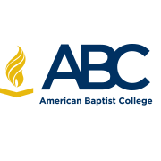

2017 Fall Book Order Instructions

1. If you are ordering books by charging them to your student account, you must order your books through the ABC Library Services. The book ordering process is very simple, but you must follow the attached instructions. You will place your order using the following email address only:
abclibrary2011@gmail.com

2. Required books will be located in the Student Portal under course description. A book list will not be emailed to you. Please refer to the student portal or your course syllabus for book information.
3. If a book is required for your class, you will need the book for your class. Failure to purchase, rent or use a book is not an option. If you have difficulty with book ordering, please let your academic advisor know as soon as possible.
4. All inquiries must come from the abcnash.edu address.
5. E-book purchases and book rentals cannot be billed to student's accounts. Students will need to purchase them on their own.
6. The primary option for book purchase will be Amazon Prime. If the Amazon Prime option is not available then books will be chosen from new or used based on your specification. If you do not specify used or new, a new book will be selected. Please keep in mind, used books usually take longer to receive.
7. Students will be responsible for returning unwanted material. The library staff will print the return label only.

